**SAGAR INSTITUTE OF RESEARCH AND TECHNOLOGY, BHOPAL (M.P.)**



**(Department of Electronics & Communication Engineering)**

**CERTIFICATE OF APPROVAL**

The undersigned certify that they have read and recommended to the Department of Electronics & Communication Engineering for acceptance, a project report entitled “**SURVEILLANCE ROBOT”** submitted by **Abhijeet Borker** in partial fulfillment for the degree of Bachelor of Technology in Electronics & Communication Engineering.

**Prof. Priya Sharma Mukesh Yadav Dr. Jyoti Jain**

**SUPERVISOR PROJECT COORDINATOR HOD EC**



**SAGAR INSTITUTE OF RESEARCH AND TECHNOLOGY, BHOPAL (M.P.)**

**(Department of Electronics & Communication Engineering)**

**DECLARATION**

**I Abhijeet Borker,** a student of **“Bachelor of Technology”** in **Sagar Institute of Research & Technology”,** session **2020-24**,Bhopal (M.P.) here by informed that the work presented n this dissertation entitled “**SURVEILLANCE ROBOT**” is the outcome of my own work, is bonafide and correct to the best of my knowledge and this work has been carried out taking care of Engineering Ethics. The work presented does not infringe any patented work and has not been submitted to any other University or anywhere else for the award of any degree or any professional diploma.

**Abhijeet Borker (0133EC201002)**



**SAGAR INSTITUTE OF RESEARCH AND TECHNOLOGY, BHOPAL (M.P.)**

**(Department of Electronics & Communication Engineering)**

**ACKNOWLEDGEMENT**

I take an opportunity to acknowledge and extend my heartfelt gratitude to my guide and the pivot of this enterprise, **Abhijeet Borker,** who is most responsible for helping me to complete this work. He/She showed me different ways to approach the problems and the need to be persistent to accomplish my goal. His/Her discernment in the choice of topic, his/her confidence in me when I doubted myself and his/her admirable guidance are some cogent reasons that make me over that without his/her support this thesis would be a chimera.

I am also thankful to **Dr.Jyoti Jain,** Head of Department of Electronics & Communication Engineering for cooperation and support to complete this work. I would also like to express my thanks to **Dr. Rajiv Srivasatava** Director SIRT Bhopal providing necessary facilities. I would also convey my Thanks to **Prof. Priya Sharma** and **Prof. Mukesh yadav** of Department of Electronics & Communication Engineering for their continuous support. Thanks are due to all the staff members and lab staff of Department of Electronics & Communication Engineering SIRT for providing all help and support.

**Abhijeet Borker (0133EC201002)**

**Anoushka Shukla (0133EC201014)**

**Gaurav Tripathi (0133EC201032)**

**Yash Ghormade (0133EC201124)**



**SAGAR INSTITUTE OF RESEARCH AND TECHNOLOGY, BHOPAL (M.P.)**

**(Department of Electronics & Communication Engineering)**

**ABSTRACT**

This project focuses on the design and development of an IoT-based surveillance robot intended for manual control. The primary objective of the robot is to navigate autonomously within a specified environment while transmitting real-time video data to a ground station via internet or Wi-Fi connectivity. The transmitted data enables human operators to remotely control the robot's movements in response to the observed surroundings. With a Raspberry Pi board serving as the central control unit, this system facilitates monitoring and intervention in potential terrorist threats worldwide. Leveraging wireless network technology, the robot's movements are remotely monitored and controlled through a web-based application, providing operators with seamless access and control over the robot's activities. Ultimately, this surveillance robot system offers a proactive approach to security and surveillance, empowering operators to respond effectively to emerging threats and maintain situational awareness in diverse environments.

**TABLE OF CONTENTS**

|  |  |
| --- | --- |
| Certificate of Approval………………………………………….  Declaration……………………………………………………… | ii  iii |
| Acknowledgement………………………………………………. | iv |
| Abstract………………………………………………………….. | v |

|  |  |  |
| --- | --- | --- |
| **CHAPTER 1** | **INTRODUCTION** | **10-14** |
| 1.1 INTRODUCTION OF PROJECT | | 10 |
| 1.2 PROBLEM STATEMENT | | 12 |
| 1.3 VISION | | 13 |
| **CHAPTER 2** | **METHODOLOGY** | **15-16** |
| **CHAPTER 3** | **SYSTEM MODEL AND LITERATURE SURVEY** | **17-20** |
| 3.1 | LITERALLY SURVEY | 17 |
| 3.2 | SYSTEM MODEL | 18 |
| **CHAPTER 4** | **PROPOSED WORK AND BLOCK DIAGR** | **22-25** |
| **CHAPTER 5** | **WORKING** | **26-29** |
| 5.1 | WORKING PRINCIPLE | 26 |
| 5.2 | WORKING | 27 |
| **CHAPTER 6** | **HARDWARE DESCRIPTION AND REAL TIME DIAGRAM** | **30-50** |
| 6.1 | Introduction | 30 |
| 6.2 | Raspberry Pi | 33 |
| 6.3 | Gas Sensor | 38 |
| 6.4 | Camera | 42 |
| 6.5 | Humidity and Temperature Sensor | 44 |
| 6.6 | Motor driver | 47 |
| **CHAPTER 7** | **CODE** | **51** |
| **CHAPTER 8** | **APPLICATION, FUTURE SCOPE AND CONCLUSION** | **55-57** |
| 8.1 | APPLICATION | 55 |
| 8.2 | FUTURE SCOPE | 57 |
| 8.3 | CONCLUSION | 59 |
| **REFRENCES** |  | **60** |

**LIST OF FIGURES**

|  |  |  |
| --- | --- | --- |
| **Fig No** | **Description of Figure** | **Page No** |
| Fig. 4.1 | Block Diagram | 24 |
| Fig. 4.1 | Circuit Diagram | 25 |
| Fig. 6.1 | Raspberry Pi | 35 |
| Fig. 6.2 | Gas Sensor | 40 |
| Fig. 6.3 | Camera | 43 |
| Fig. 6.4 | Humidity and Temperature Sensor | 46 |
| Fig. 6.5 | Motor Driver | 48 |
| Fig. 6.6 | Real Time Diagram | 50 |

**LIST OF TABLE**

|  |  |  |
| --- | --- | --- |
| **Table No** | **Description of Figure** | **Page No** |
| Table. 2.1.1 | Literature Survey Comparison Table | 21 |
| Table 6.2.1 | Raspberry Pi-3 Pin Configuration | 36-37 |
| Table 6.2.2 | Raspberry Board Connection | 37 |
| Table 6.3.1 | MQ2 Sensor Pin Configuration | 41 |
| Table 6.4.1 | AHT10 Pin out Configuration | 46 |
| Table 6.5.1 | MX1508 DC Motor Driver Pin out | 49 |

### 

### ABBREVIATIONS

|  |  |
| --- | --- |
| Wifi | Wireless Fidelity |
| PI | Raspberry Pi |
| Ui | User Interface |
| GPU | General Processing Unit |
| CPU | Central Processing Unit |
| LINUX | Lovable Intellect Not Using XP |
| OS | Operating System |
| USB | Universal Serial Bus |
| SD Card | Secure Digital Card |
| LPG | Liquid Petroleum Gas |
| LED | Light-emitting diode |

**CHAPTER I**

**INTRODUCTION**

* 1. **Introduction of Project**

Surveillance, the practice of systematically examining land for various purposes, has traditionally involved labor-intensive and time-consuming methods. These methods have been used for mineral extraction, construction planning, assessing agricultural suitability, and conducting military reconnaissance. Surveying involves precise measurement of horizontal distances, directions, angles, and elevations. Historically, this has been done manually using basic tools such as ropes, metal detectors, and deep digging equipment.

To revolutionize this field, we propose the development of an advanced surveillance robot. This innovative robot is designed to collect comprehensive ground data and transmit it to the cloud for analysis. With capabilities to detect metals deep underground, identify archaeological sites, and locate mineral deposits, this robot brings significant improvements to traditional surveying methods. Furthermore, it can detect various gases including shale gas, alcohol, LPG, and CNG, monitor temperature, and provide real-time video data.

The surveillance robot is equipped with a suite of sophisticated sensors: gas sensors, temperature and humidity sensors, a camera, a metal detector, and a PIR sensor for motion detection. At its core, the Raspberry Pi serves as the central controller, managing the collection and transmission of data. This real-time data is then accessible via a mobile application, enabling users to view and analyze the information remotely. The robot can be wirelessly controlled through the same application, facilitating seamless navigation and data acquisition.

The robot's primary function is to navigate a designated environment while transmitting real-time data, including video, to a ground station over the internet or Wi-Fi. This capability allows a human operator to remotely control the robot, ensuring precise and efficient surveillance. By utilizing modern sensor technology and cloud computing, this robot offers a versatile and efficient solution for a wide range of applications.

The surveillance robot's applications span across various sectors. In the military, it can be employed to monitor terrorist activities, detect land mines, identify warheads, and track human movements, thereby enhancing security and situational awareness in conflict zones. In healthcare, the robot can function as a patient monitoring device, providing real-time data to healthcare providers. In the tourism industry, it can serve as an interactive guide, offering accurate information and directions to visitors. For security purposes, its human detection system can identify intruders or unauthorized personnel. In archaeological surveys, the robot's metal detection capabilities can significantly reduce the reliance on heavy machinery, enabling more efficient and less invasive exploration of historical sites.

This surveillance robot represents a significant advancement in the field of automated monitoring and data collection. Its ability to provide real-time data and remote control enhances operational efficiency, safety, and situational awareness in various environments. By leveraging modern sensor technology and cloud computing, it offers a versatile and efficient solution for a wide range of applications.

In counter-terrorism efforts, this system will play a crucial role by allowing the remote monitoring and control of robots via the internet through the Raspberry Pi board. The wireless network-based web application facilitates comprehensive monitoring and control of robotic movements, ensuring responsiveness and adaptability in dynamic situations. This is particularly valuable in scenarios where human presence is risky or impractical.

Furthermore, the surveillance robot's potential extends to environmental monitoring, where it can be used to track and report on changes in environmental conditions, detect pollution levels, and monitor wildlife. This makes it an invaluable tool for conservation efforts and environmental protection.

In summary, the surveillance robot embodies the future of automated monitoring. By providing a robust and adaptable tool for enhancing security, simplifying operations, and expanding the horizons of surveillance, it stands out as a guardian of safety and efficiency. Its multifaceted applications and advanced technological integration make it an indispensable asset in an increasingly interconnected world. This robot not only advances traditional surveying methods but also introduces new possibilities for remote and automated monitoring across diverse fields, ensuring a safer and more efficient future.

The introduction of this surveillance robot marks a pivotal step towards modernizing and improving how we collect and analyze data. It is poised to revolutionize the way we approach surveying, security, healthcare, tourism, and environmental monitoring, positioning itself as a crucial tool for tackling the challenges of the modern world. By embracing this technology, we can achieve greater accuracy, efficiency, and safety in our operations, ultimately contributing to a better and more secure future.

* 1. **PROBLEM STATEMENT**

The problem statement of a surveillance robot is to develop a robot that can monitor and gather information in various environments for security purposes. It should be able to navigate autonomously, detect and track objects, and transmit data in real-time. In this project we will be working on following problems.

* + 1. **On-ground Surveillance:**

Historically, ground surveillance relied on bulky machinery and manpower, rendering certain terrains inaccessible. To overcome this limitation, the project focuses on designing a compact robot capable of maneuvering through challenging terrains. By minimizing size and enhancing mobility, the robot can access previously inaccessible areas, ensuring comprehensive surveillance coverage.

**1.2.2 Video Surveillance:**

Traditional surveillance systems were restricted to ground-level observations. To expand the scope of surveillance, the project integrates cameras into the robot, effectively granting it a 360-degree field of view. These cameras serve as the robot's eyes, providing real-time visual data essential for monitoring and threat detection. By equipping the robot with this capability, it functions akin to a guide dog, offering enhanced situational awareness.

**1.2.3 Detection of Gases:**

India's diverse terrain presents challenges in detecting natural and shale gases, particularly in remote and high-altitude regions. To address this, the project incorporates gas sensors into the robot, facilitating the detection of these gases in challenging environments. By leveraging the robot's mobility and sensor capabilities, it can identify and map gas concentrations, contributing to environmental monitoring and resource exploration efforts.

**1.2.4 Temperature and Weather Monitoring:**

Adverse weather conditions often hinder surveillance operations, compromising data quality and equipment durability. To mitigate these challenges, the robot features temperature sensors to monitor environmental conditions. By providing real-time data on temperature and humidity, the robot enhances situational awareness, enabling informed decision-making and adaptive surveillance strategies in varying weather conditions.

* 1. **VISION**

The vision for the surveillance robot is to revolutionize the way we approach monitoring, data collection, and analysis across a multitude of sectors, ultimately enhancing security, efficiency, and operational effectiveness in an increasingly interconnected world. At the heart of this vision is the development of an autonomous, intelligent robot equipped with state-of-the-art sensors and technology, capable of performing complex surveillance tasks that were once labor-intensive and time-consuming.

Our surveillance robot aims to transform traditional surveying methods by integrating modern sensor technology and cloud computing. This innovative approach allows for real-time data collection and transmission, enabling precise and efficient monitoring of various environments. By equipping the robot with gas sensors, temperature and humidity sensors, a camera, a metal detector, and a PIR sensor, we envision a tool that can gather comprehensive data on its surroundings, detect deep underground metals, identify gases such as shale gas, alcohol, LPG, and CNG, and monitor environmental conditions with unparalleled accuracy.

A critical aspect of our vision is the robot's ability to transmit real-time video and data to a remote ground station over the internet or Wi-Fi. This capability allows human operators to control the robot wirelessly, using a mobile application to navigate and gather information efficiently. The real-time data accessibility ensures that decision-makers have the most up-to-date information at their fingertips, enhancing situational awareness and enabling rapid response to dynamic scenarios.

In the military sector, our surveillance robot is envisioned as a vital tool for monitoring terrorist activities, detecting land mines, identifying warheads, and tracking human movements. This enhances security and situational awareness in conflict zones, potentially saving lives and improving mission outcomes. In healthcare, the robot can serve as a patient monitoring device, providing real-time health data to medical professionals and improving patient care. For the tourism industry, the robot can act as an interactive guide, offering accurate information and directions to visitors, enriching their experience. In security, the robot's human detection system can identify intruders or unauthorized personnel, safeguarding properties and ensuring safety.

The ultimate goal is to create a versatile and adaptable surveillance robot that addresses the diverse needs of various sectors, providing a robust solution for modern challenges. By leveraging advanced technology, our surveillance robot aims to enhance operational efficiency, safety, and situational awareness, setting new standards for automated monitoring and data collection.

In summary, the vision for our surveillance robot is to pave the way for a future where automated, intelligent monitoring systems play a crucial role in improving security, efficiency, and data accuracy across multiple domains. By embracing this technology, we aim to revolutionize traditional methods, introduce new possibilities for remote and automated monitoring, and contribute to a safer, more efficient, and more informed world.

**CHAPTER II**

**METHODOLOGY**

The methodology for developing the surveillance robot system involves integrating a camera with Raspberry Pi for real-time video surveillance. Operated via a mobile application, the robot incorporates various sensors for weather and environmental monitoring. Utilizing Raspberry Pi microcontroller reduces cost and complexity while ensuring secured communication protocols. The two-part system design enables users to interact with the robot through a mobile device, facilitating remote control and monitoring. Enhanced security measures prioritize safeguarding user belongings, with the primary goal of building a surveillance rover for securely transmitting live video footage. This comprehensive approach addresses evolving surveillance and security needs effectively.

**2.1 Integration of Camera with Raspberry Pi:**

The first step in the methodology involves interfacing a camera with the Raspberry Pi microcontroller to achieve real-time video surveillance capabilities. This integration allows the surveillance robot to capture live video footage of its surroundings, providing operators with visual insights into the monitored area.

**2.2 Mobile Application for Robot Operation:**

The surveillance robot is designed to be operated using a mobile application, offering users flexibility and convenience in controlling the robot's movements and functions. The mobile application serves as the user interface, allowing operators to remotely navigate the robot and access its surveillance capabilities from anywhere with internet connectivity.

**2.3 INTEGRATION OF VARIOUS SENSORS:**

Various sensors are integrated into the surveillance robot to enable real-time weather, temperature, and environmental condition monitoring of the area. These sensors provide valuable data insights to operators, allowing them to assess environmental conditions and make informed decisions in surveillance and security operations.

**2.4 Utilization of Raspberry Pi Microcontroller:**

The use of a Raspberry Pi microcontroller in the surveillance robot system contributes to cost reduction and complexity simplification. The Raspberry Pi serves as the central control unit, managing communication with the user interface, processing sensor data, and executing control algorithms. Its versatility and compatibility with various peripherals make it an ideal choice for the surveillance robot's control system.

**2.5 Secured Communication Protocol:**

Communication between the surveillance robot and the user interface occurs in a secured manner, ensuring data integrity and confidentiality. Encryption algorithms and authentication mechanisms are implemented to mitigate the risk of unauthorized access or tampering, enhancing the overall security of the surveillance operation.

**2.6 Two-Part System Design:**

The surveillance robot system consists of two main parts: the user portion and the robot. The user interacts with the robot using a portable computer or mobile device, accessing a mobile application as the user interface. Wi-Fi technology facilitates communication between the user interface and the robot, enabling seamless remote control and monitoring.

**2.7 Enhanced Security Measures:**

Given the increasing complexity of security threats, the surveillance robot system prioritizes security measures to safeguard user belongings and data. The primary goal is to build a surveillance rover capable of securely transmitting live video footage of the environment to users through a mobile application. This ensures that users can remotely monitor their belongings from anywhere in the world, enhancing security and peace of mind.

**CHAPTER –III**

**SYSTEM MODEL AND LITERATURE SURVEY**

**Modernizing Surveillance through Robot:**

The system model and literature survey are essential components of our project aimed at modernizing surveillance through innovative technological solutions. In this section, we explore existing research, technologies, and methodologies relevant to our project while presenting a comprehensive system model that integrates these findings into our solution.

**2.1 Literature Survey:**

The literature survey provides a deep dive into existing research, studies, and technologies related to surveillance, particularly focusing on video surveillance, gas detection and temperature monitoring. It encompasses a review of academic papers, industry reports, and real-world case studies to identify trends, challenges, and best practices in the field.

Key areas covered in the literature survey include:

**2.1.1 Real Time Video Streaming:**

Modernizing surveillance through robots involves incorporating real-time video streaming capabilities, enabling users to access live footage from remote locations. By leveraging high-definition cameras and advanced communication technologies, such as Wi-Fi or 5G, surveillance robots can provide instant visual feedback to operators, enhancing situational awareness and enabling swift response to security threats. Real-time video streaming also facilitates remote monitoring, allowing users to oversee operations without being physically present, thereby optimizing resource allocation and operational efficiency.

**2.1.2 Gas Detection:**

To enhance surveillance capabilities, modernized robots are equipped with gas detection sensors, enabling them to detect and monitor hazardous gases in the environment. These sensors can identify a wide range of gases, including natural gases, industrial emissions, and chemical pollutants, providing valuable insights into environmental safety and security. By integrating gas detection technology into surveillance robots, organizations can proactively identify potential hazards, mitigate risks, and ensure the safety of personnel and assets in various industrial, commercial, and residential settings.

**2.1.3 Temperature monitoring:**

Temperature monitoring is a critical aspect of modern surveillance, especially in environments where temperature fluctuations can impact operational efficiency and safety. Surveillance robots are equipped with temperature sensors capable of measuring ambient temperature, humidity levels, and thermal anomalies in real-time. This enables operators to identify areas of concern, such as overheating equipment or fire hazards, and take timely preventive measures to mitigate risks. By incorporating temperature monitoring capabilities, surveillance robots contribute to enhanced situational awareness and proactive risk management in diverse environments.

**2.1.4 Compact design**:

Modernizing surveillance through robots involves the development of compact designs that optimize mobility and versatility without compromising functionality. Compact surveillance robots are designed to navigate tight spaces, negotiate obstacles, and access hard-to-reach areas with ease, making them well-suited for indoor and outdoor surveillance applications. By minimizing size and weight, these robots can operate efficiently in diverse environments, including urban landscapes, industrial facilities, and hazardous zones. Additionally, compact designs enhance portability and deployment flexibility, allowing surveillance robots to be rapidly deployed in response to emerging security threats or emergency situations.

**2.2 System Model:**

Building upon the insights gained from the literature survey, we present a comprehensive system model that integrates the latest technologies and methodologies into our Surveillance Robot. The system model encompasses both hardware and software components, designed to provide a multi-layered approach to enhancing Real Time Video Surveillance.

**2.2.1 Hardware Components:**

**Raspberry Pi:** Serves as the central processing unit, interfacing with sensors and communication modules.

**Sensors:** Gas Sensor, Temperature Sensor, Camera and Motors

**Communication Modules:** Wifi Module, Web Server

**Power Management System:** Ensures uninterrupted operation through batteries and efficient power management circuits.

**2.2.2 Software Components:**

In the development of surveillance robots, several critical software components are integral to ensuring seamless operation and effective data management. The foremost among these is sensor data processing software, which plays a pivotal role in interpreting and analyzing data collected from the robot's onboard sensors. This software is responsible for processing raw sensor data, applying algorithms for feature extraction, and performing data fusion to generate meaningful insights about the robot's surroundings. Through techniques such as signal filtering, noise reduction, and object detection, sensor data processing software extracts relevant information from sensor inputs, enabling the robot to make informed decisions in real-time.

Additionally, the user interface (UI) software component serves as the bridge between human operators and the robot's functionalities. The UI presents information such as live video feeds, sensor data readings, and system status updates in a user-friendly format, facilitating remote monitoring and control of the robot's activities. Furthermore, communication protocols are essential for enabling seamless communication between the surveillance robot and external systems, including remote control stations and command centers. These protocols define the rules and standards for data exchange, ensuring reliable communication and interoperability with existing surveillance infrastructure. Through the integration of these software components, surveillance robots can perform complex surveillance tasks efficiently and effectively, enhancing security and safety in various environments.

**2.2.3 Conclusion:**

In conclusion, the development of surveillance robots represents a significant advancement in the field of security and surveillance. Through the integration of critical software components such as sensor data processing, user interface, and communication protocols, these robots have become indispensable tools for enhancing situational awareness, mitigating risks, and safeguarding lives and assets. The sensor data processing software enables robots to interpret and analyze data collected from onboard sensors, empowering them to make informed decisions in real-time. Meanwhile, user interface software facilitates seamless interaction between human operators and the robot's functionalities, enabling remote monitoring and control. Additionally, communication protocols ensure reliable data exchange between the robot and external systems, further enhancing its capabilities.

By leveraging these software components, surveillance robots can navigate diverse environments, detect anomalies, and respond swiftly to security threats. Whether deployed in industrial facilities, urban areas, or hazardous zones, these robots play a crucial role in enhancing security measures and ensuring the safety of personnel and assets. Moreover, ongoing advancements in software technology continue to expand the capabilities of surveillance robots, enabling them to perform increasingly complex tasks with greater efficiency and precision.

Overall, the continued development and deployment of surveillance robots hold immense potential for improving security and surveillance operations across various sectors. With their ability to provide real-time insights, facilitate proactive decision-making, and adapt to evolving threats, surveillance robots are poised to become indispensable assets in the quest for safer and more secure environments.

**LITERATURE SURVEY COMPARISION TABLE**

|  |  |  |  |  |
| --- | --- | --- | --- | --- |
| **S.no** | **Author** | **Tittle** | **Source** | **Finding** |
| 1 | Shaikh Shoeb | Surveillance Robot controlled using an Android app  (2015) | <https://core.ac.uk/download/pdf/55305159.pdf> | Project was build using Arduino. we have deve-loped using raspberry pi |
| 2 | [Harshitha R.](https://ieeexplore.ieee.org/author/37089105839) | Surveillance Robot Using Arduino  (2018) | <https://ieeexplore.ieee.org/document/8437086> | System was built but IOT was not implemented. |
| 3 | L. Naveen | IOT Based Surveillance Robot  (2019) | [https://](https://www.ijert.org/research/iot-based-surveillance-robot-IJERTV7IS030061.pdf)[www.ijert.org/research/iot-based surv- eillance-robot-IJER- TV7IS030061.pdf](http://www.ijert.org/research/iot-based%20surv-%20eillance-robot-IJER-%20TV7IS030061.pdf) | Robot was manually operation |
| 4 | R.Rangnath | Rb-Watcher (2021) | <https://robotnik.eu/rb-watcher-robotnik-announces-the-new-mobile-surveillance-robot/> | Roboat was not having real time video survellence and weather detection |
| 5 | Preeti Raj | Autonomous Robots: The Future of Security and Surveillance? (2022) | <https://www.plainconcepts.com/autonomous-robots-security/> | Project didn’t had human detection support system. |

**Table. 2.1.1**

**CHAPTER –IV**

**PROPOSED WORK AND BLOCK DIAGRAM**

Taking Reference of “**Autonomous Robots: The Future of Security and Surveillance?”** the research paper published on 2022, we are proposing our surveillance robot. Which involves designing and implementing a robot that can autonomously navigate and monitor an area for surveillance purposes. It will include features such as object detection, tracking, live video streaming, and remote control capabilities. The goal is to develop a reliable and efficient robot that can enhance security and situational awareness in various environments.

Surveillance robot integrates advanced technologies using Raspberry Pi as its core, equipped with a gas sensor, temperature sensor, camera, and metal detector for comprehensive monitoring capabilities.

* The **gas sensor** ensures the detection of hazardous fumes or leaks, enabling swift response to potential threats in industrial or domestic environments.
* The **temperature sensor** provides real-time environmental data, aiding in fire prevention or identifying abnormal temperature fluctuations.
* The inclusion of a high-resolution **camera** enhances visual surveillance, allowing remote monitoring and capturing crucial footage for security purposes.
* The **metal detector** reinforces the robot's capabilities by identifying metallic objects, crucial for security applications and contraband detection.
* Operational autonomy and versatility are achieved through **Raspberry Pi's** programmability, enabling the robot to execute predefined tasks or respond dynamically to detected anomalies.

The integration of these sensors ensures a multifaceted approach to surveillance, making the robot suitable for applications ranging from industrial safety to home security. The system's compact design and cost-effectiveness, owing to the Raspberry Pi platform, make it an efficient and accessible solution for enhancing situational awareness in various settings.

**BLOCK DIAGRAM**



CLOUD

**Fig. 4.1**

Gas Sensor

Temprature Sensor

DATA

Camera

Motor Driver

Motor

Raspberry-Pi

**CIRCUIT DIAGRAM**

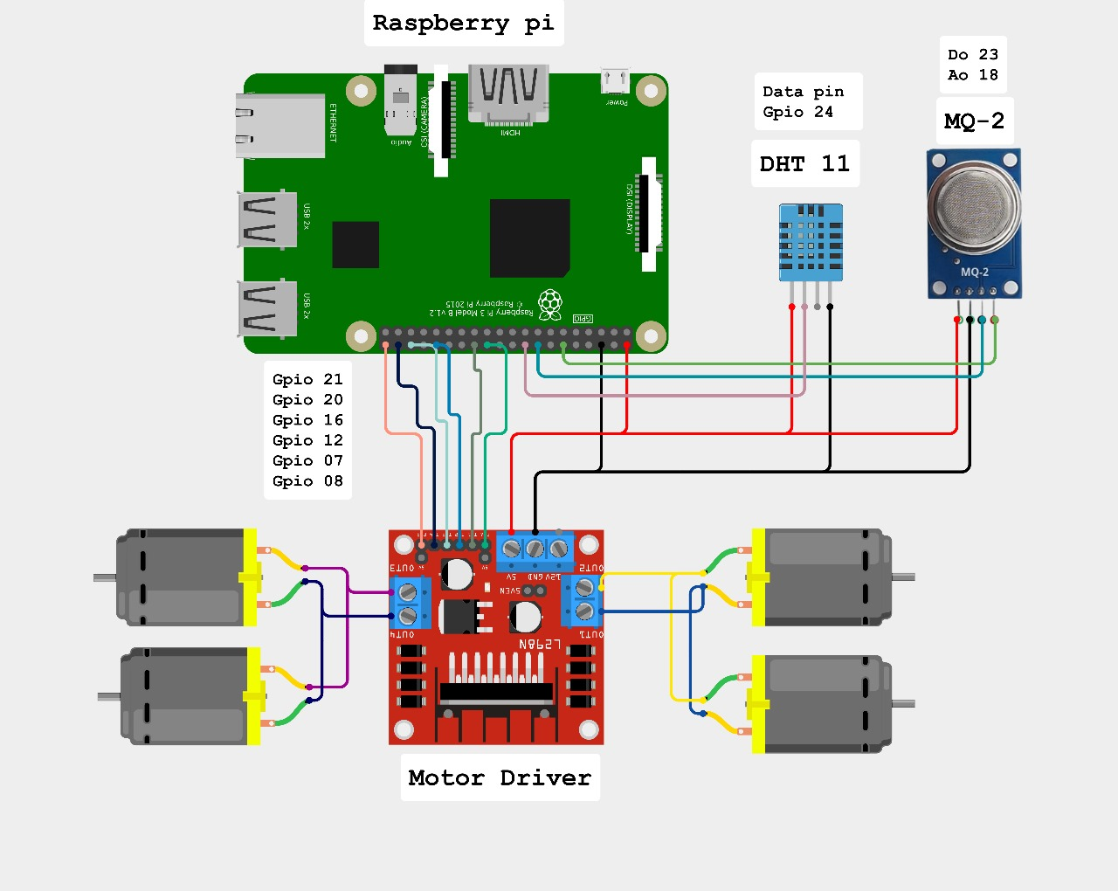

**Fig. 4.2**

**CHAPTER –V**

**WORKING PRINCIPLE AND WORKING**

**5.1 Working principle**

Surveillance robots play a pivotal role in enhancing security, monitoring environments, and providing real-time information in a variety of applications, from military and law enforcement to industrial and commercial settings. The working principle of a surveillance robot is rooted in a combination of cutting-edge technologies, including sensors, communication systems, and advanced software. Here's a concise overview of the working principles of a surveillance robot:

**5.1.1 Sensors and Perception:**

Surveillance robots will be equipped with a multitude of sensors, including cameras, metal Detector, ultrasonic sensors and Human detection. These sensors provide the robot with the ability to perceive its environment. Cameras, in particular, capture visual data that is vital for recognizing objects, people, or unusual activities.

**5.1.2 Navigation and Mobility:**

To move autonomously, surveillance robots often employ wheels or tracks for ground-based movement or propellers for aerial surveillance. These robots integrate navigation systems such as GPS, IMUs (Inertial Measurement Units), and obstacle detection algorithms to avoid collisions and follow predefined paths.

**5.1.3 Data Processing and Analysis:**

The data collected by the sensors are processed in real-time by onboard Rasberry Pi. Advanced machine learning and computer vision algorithms are employed to interpret this data. Object recognition, tracking, and anomaly detection algorithms help the robot understand its environment, identify potential threats, and distinguish between normal and suspicious activities.

**5.1.4 Communication:**

Surveillance robots are typically connected to a central command center or operators via wireless communication channels, such as Wi-Fi. This enables real-time data transmission, video streaming, and remote control. In some cases, autonomous robots can make decisions independently, while others require human intervention.

**5.1.6 Alert and Response:**

When a surveillance robot detects a security breach or an unusual event, it can trigger alerts or notifications to the monitoring personnel. This allows for timely responses, including deploying security personnel to the scene or taking autonomous actions like sounding alarms, illuminating areas, or even detaining intruders, depending on the robot's capabilities.

**5.2 Working**

The development of an IoT-based surveillance robot system entails a comprehensive framework that integrates various components and technologies to achieve real-time monitoring, detection, and control of environmental conditions. This framework leverages Raspberry Pi as the central processing unit, incorporates multiple sensors for data collection, implements wireless communication protocols, and utilizes advanced frameworks for data transmission. By combining these elements, the surveillance robot system offers enhanced surveillance capabilities, enabling operators to monitor, detect, and respond to security threats effectively.

* Raspberry Pi receives live data collected from different sensors embedded with it and then transfer to Things board dashboard using Wi-Fi.
* These different sensors are Temperature sensor humidity sensor, Metal Detector sensor, Gas Sensor, PIR sensor and camera for live video streaming.
* The monitoring and controlling of robot is done by wireless network by using a web application Things board.
* Camera video transmission via internet is done using Duplicity framework.
* The PIR sensor detects movement of a person or an animal enters into a surveillance area and can detect the landmines by using metal detector sensors.
* This system also detects the human presence in the field and senses present situation of the environment.

**5.2.1 Data Acquisition and Transmission:**

Raspberry Pi serves as the core component for receiving live data from embedded sensors and transmitting it to the ThingsBoard dashboard via Wi-Fi connectivity. This process facilitates continuous data collection from various sensors, including temperature, humidity, gas levels, metal detection, PIR (Passive Infrared), and cameras for live video streaming. By integrating Raspberry Pi with Wi-Fi technology, the surveillance robot system achieves seamless data transmission, enabling real-time monitoring and analysis.

**5.2.2 Sensor Integration:**

The surveillance robot system incorporates a diverse range of sensors to capture essential environmental parameters and detect potential security threats. These sensors include temperature sensors, humidity sensors, metal detectors, gas sensors, PIR sensors, and cameras. The integration of multiple sensors enables comprehensive data collection, allowing operators to monitor environmental conditions, detect anomalies, and respond to security incidents promptly.

**5.2.3 Control and Monitoring Mechanisms:**

Wireless network connectivity enables the monitoring and control of the surveillance robot system through a web application hosted on the Things Board platform. Operators can remotely access the web application to monitor sensor readings, control robot movements, and receive real-time alerts for abnormal events. This web-based control interface offers flexibility and convenience in managing surveillance operations, enhancing situational awareness and response capabilities.

**5.2.4 Video Transmission Framework:**

Video transmission from the surveillance robot's camera to the internet is facilitated by the Duplicity framework. This framework enables seamless streaming of live video footage, allowing operators to visually assess the monitored environment in real-time. By leveraging the Duplicity framework, the surveillance robot system enhances its surveillance capabilities, enabling operators to remotely view and analyze video data for security and monitoring purposes.

**5.2.5 Advanced Detection Capabilities:**

The surveillance robot system employs advanced sensors such as PIR sensors and metal detectors to enhance its detection capabilities. The PIR sensor detects movement of individuals or animals entering the surveillance area, providing early warning of potential security threats. Additionally, metal detectors enable the detection of landmines or metallic objects buried in the ground, further enhancing security measures and ensuring environmental safety.

**5.2.6 Human Presence Detection and Environmental Sensing:**

Beyond security threats, the surveillance robot system is equipped to detect human presence and assess current environmental conditions. This functionality enables the system to identify potential risks, such as unauthorized intrusions or hazardous environmental factors, and initiate appropriate responses. By continuously monitoring human presence and environmental parameters, the surveillance robot system contributes to enhanced safety and security in various environments.

**CHAPTER-VI**

**HARDWARE DESCRIPTION AND REAL TIME DIAGRAM**

**6.1 Introduction**

The hardware components utilized in surveillance robots play a pivotal role in enabling comprehensive monitoring, data collection, and analysis. Among the array of hardware employed in surveillance robots, several key components stand out for their indispensable contributions to the functionality and effectiveness of these systems. From environmental monitoring to visual perception and locomotion, each hardware element serves a unique purpose in enhancing the capabilities of surveillance robots.

**6.1.1 Raspberry Pi:**

Raspberry Pi is a versatile single-board computer commonly used in surveillance robots for processing data, controlling peripherals, and running software applications. As the brain of the robot, Raspberry Pi provides computational power, storage capacity, and connectivity options essential for executing complex algorithms, interfacing with sensors and actuators, and facilitating communication with external systems. Its compact size, low power consumption, and affordability make Raspberry Pi an ideal platform for powering surveillance robots.

**6.1.2 Camera:**

Cameras are perhaps the most recognizable hardware component in surveillance robots, serving as the robot's primary means of visual perception. Equipped with high-resolution cameras, surveillance robots can capture live video footage, still images, and panoramic views of their surroundings. These cameras enable operators to remotely monitor areas of interest, identify security threats, and gather visual evidence for analysis and response.

**6.1.3 Motor Driver:**

Motor drivers are essential hardware components responsible for controlling the movement and operation of motors in surveillance robots. By regulating the voltage and current supplied to the motors, motor drivers enable precise control of the robot's speed, direction, and maneuverability. This allows surveillance robots to navigate diverse terrains, overcome obstacles, and execute complex motion sequences with accuracy and efficiency.

**6.1.4 Gas Sensor:**

Gas sensors are critical components employed in surveillance robots for detecting and monitoring the presence of hazardous gases in the environment. These sensors can identify a wide range of gases, including carbon monoxide, methane, and volatile organic compounds, providing early warning of potential safety hazards or environmental pollution. Gas sensors enhance the situational awareness of surveillance robots, enabling them to assess air quality, detect leaks, and respond promptly to gas-related emergencies.

**6.1.5 Motor:**

Motors are fundamental hardware components that drive the locomotion and mechanical operations of surveillance robots. Whether propelling the robot's wheels, rotating its cameras, or articulating its manipulator arms, motors translate electrical energy into mechanical motion, enabling the robot to perform a wide range of tasks. The selection of motors depends on factors such as payload capacity, speed requirements, and power efficiency, ensuring optimal performance in various operating conditions.

**6.1.6** **Humidity sensors:**

Humidity sensors are essential components of surveillance robots, tasked with monitoring and measuring the moisture levels in the robot's surrounding environment. By providing real-time humidity data, these sensors enable the robot to assess environmental conditions, detect changes in humidity levels, and identify potential risks such as condensation or moisture-related damage to equipment.

**6.1.7 Power Supply:**

Power supply units are vital hardware components that provide electrical energy to power the operation of surveillance robots. Whether through rechargeable batteries, solar panels, or external power sources, a reliable power supply is essential for ensuring continuous operation and autonomy of the robot. Power supply units must be robust, efficient, and scalable to meet the energy demands of surveillance robots operating in diverse environments and applications.

**6.1.8 Charging Cable:**

Charging Cable are essential hardware interfaces incorporated into surveillance robots for replenishing the energy stored in their batteries. These ports allow operators to connect the robot to a power source for recharging, ensuring uninterrupted operation and prolonged mission duration.

**6.2 RASPBERRY PI**

RASPBERRY PI is a small-card sized computer capable of performing various functionalities such as in surveillance systems, military application, industrial application, home application, etc. It operates in the open source ecosystem: it runs Linux (a variety of distributions), and its main supported operating system, Pi OS, is open source and runs a suite of open source software. The Raspberry Pi Foundation contributes to the Linux kernel and various other open source projects as well as releasing much of its own software as open source. It has the ability to interact with the outside world, and has been used in a wide array of digital maker projects, from music machines and parent detectors to weather stations and tweeting birdhouses with infra-red cameras. We want to see the Raspberry Pi being used by kids all over the world to learn to program and understand how computers work.

Whilst maintaining the popular board format the Raspberry Pi 3 Model B brings a more powerful processer, 10x faster than the first generation Raspberry Pi. Additionally it adds wireless LAN & Bluetooth connectivity making it the ideal solution for powerful connected designs. With its built-in wireless connectivity, the new Raspberry Pi is clearly positioned as a low-cost hub for Internet of Things devices, or as the flexible, low-cost basis of new types of connected gadgets. The new bump to a 2.5 amps power source means it will be able to power more complex USB devices without the need for a second power cable.

The Broadcom BCM2835 SoC used in the first generation Raspberry Pi includes a 700 MHz 32-bit ARM1176JZF-S processor, Video Core IV graphics processing unit (GPU), and RAM. It has a level 1 cache of 16 KB and a level 2 cache of 128 KB. The level 2 cache is used primarily by the GPU. The SoC is stacked underneath the RAM chip, so only its edge is visible. The ARM1176JZ(F)-S is the same CPU used in the original iPhone, although at a higher clock rate, and mated with a much faster GPU.

**RASPBERRY PI 3** is a development board in PI series. It can be considered as a single board computer that works on LINUX operating system. The board not only has tons of features it also has terrific processing speed making it suitable for advanced applications. PI board is specifically designed for hobbyist and engineers who are interested in LINUX systems and IoT (Internet of Things).

PI is simply a **COMPUTER ON A SINGLE BOARD** so it cannot be used like ARDUINO development boards. For the PI to start working we need to first install OPERATING SYSTEM. This feature is similar to our PC. The PI has dedicated OS for it; any other OS will not work.

**6.2.1 Programming of PI**

Take the 16GB micro SD card and dedicate it specifically for PI OS.

1. Choose and Download OS software. [<https://www.raspberrypi.org/downloads/>] (‘NOOBS’ recommended for beginners )
2. Format the SD card and install OS on to the SD memory card using convenient methods.
3. Take the SD card after OS installation and insert it in PI board.
4. Connect monitor, keyboard and mouse
5. Power the board with micro USB connector
6. Once the power is tuned ON the PI will run on the OS installed in the memory card and will start from boot.
7. Once all drivers are checked the PI will ask for authorization, this is set by default and can be changed.
8. After authorization you will reach desktop where all application program development starts.

On the PI you can download application programs required for your use and can directly install as you do for your PC. After that you can work on developing required program and get the PI run the developed programs.

**Raspberry Pi 3**

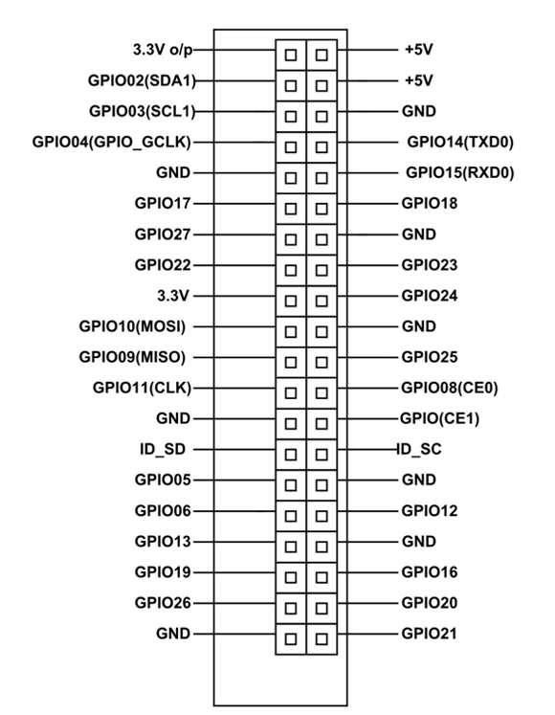

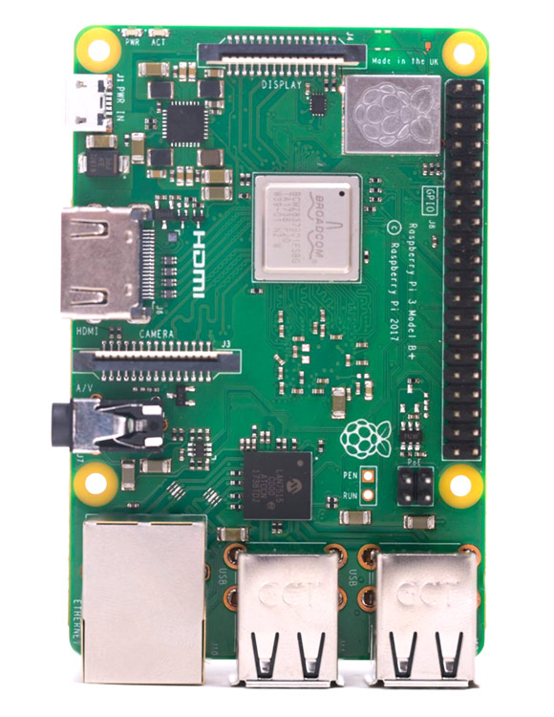

**Fig. 6.1**

### ****Raspberry Pi-3 Pin Configuration****

|  |  |  |
| --- | --- | --- |
| **PIN GROUP** | **PIN NAME** | **DESCRIPTION** |
| POWER SOURCE | +5V, +3.3V, GND and Vin | +5V -power output  +3.3V -power output  GND – GROUND pin |
| COMMUNICATION INTERFACE | UART Interface(RXD, TXD)  [(GPIO15,GPIO14)] | UART (Universal Asynchronous Receiver Transmitter) used for interfacing sensors and other devices. |
| SPI Interface(MOSI, MISO, CLK,CE) x 2  [SPI0-(GPIO10 ,GPIO9, GPIO11 ,GPIO8)]  [SPI1--(GPIO20 ,GPIO19, GPIO21 ,GPIO7)] | SPI (Serial Peripheral Interface) used for communicating with other boards or peripherals. |  |
| TWI Interface(SDA, SCL) x 2  [(GPIO2, GPIO3)]  [(ID_SD,ID_SC)] | TWI (Two Wire Interface) Interface can be used to connect peripherals. |  |
| INPUT OUTPUT PINS | 26 I/O | Although these some pins have multiple functions they can be considered as I/O pins. |
| PWM | Hardware PWM available on GPIO12, GPIO13, GPIO18, GPIO19 | These 4 channels can provide PWM (Pulse Width Modulation) outputs.  *Software PWM available on all pins |
| EXTERNAL INTERRUPTS | All I/O | In the board all I/O pins can be used as Interrupts. |

**Table 6.2.1**

### ****Board Connectors****

|  |  |
| --- | --- |
| **Name** | **Description** |
| **Ethernet** | Base T Ethernet Socket |
| **USB** | 2.0 (Four sockets) |
| **Audio Output** | 3.5mm Jack and HDMI |
| **Video output** | HDMI |
| **Camera Connector** | 15-pin MIPI Camera Serial Interface (CSI-2) |
| **Display Connector** | Display Serial Interface (DSI) 15 way flat flex cable connector with two data lanes and a clock lane. |
| **Memory Card Slot** | Push/Pull Micro SDIO |

**Table. 6.2.2**

**6.3 GAS SENSOR (MQ2)**

The MQ-2 Gas sensor can detect or measure gasses like LPG, Alcohol, Propane, Hydrogen, CO, and even methane. The module version of this sensor comes with a Digital Pin which makes this sensor to operate even without a microcontroller and that comes in handy when you are only trying to detect one particular gas. When it comes to measuring the gas in ppm the analog pin has to be used, the analog pin also TTL driven and works on 5V and hence can be used with most common microcontrollers.

We can either use the digital pin or the analog pin to accomplish this. Simply power the module with 5V and you should notice the power LED on the module to glow and when no gas it detected the output LED will remain turned off meaning the digital output pin will be 0V. Remember that these sensors have to be kept on for pre-heating time (mentioned in features above) before you can actually work with it. Now, introduce the sensor to the gas you want to detect and you should see the output LED to go high along with the digital pin, if not use the potentiometer until the output gets high. Now every time your sensor gets introduced to this gas at this particular concentration the digital pin will go high (5V) else will remain low (0V).

You can also use the analog pin to achieve the same thing. Read the analog values (0-5V) using a microcontroller, this value will be directly proportional to the concentration of the gas to which the sensor detects. You can experiment with this values and check how the sensor reacts to different concentration of gas and develop your program accordingly.

**Features**

* Operating Voltage is +5V
* Can be used to Measure or detect LPG, Alcohol, Propane, Hydrogen, CO and even methane
* Analog output voltage: 0V to 5V
* Digital Output Voltage: 0V or 5V (TTL Logic)
* Preheat duration 20 seconds
* Can be used as a Digital or analog sensor
* The Sensitivity of Digital pin can be varied using the potentiometer

**Application**

* Detects or measure Gases like LPG, Alcohol, Propane, Hydrogen, CO and even methane
* Air quality monitor
* Gas leak alarm
* Safety standard maintenance
* Maintaining environment standards in hospitals

**MQ2 Gas sensor**

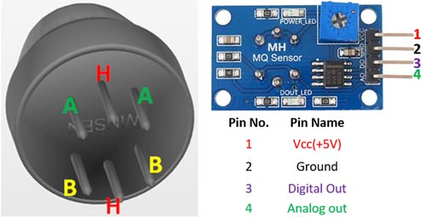

**Fig. 6.2**

|  |  |  |
| --- | --- | --- |
| **Pin No:** | **Pin Name:** | **Description** |
| **For Module** | | |
| 1 | Vcc | This pin powers the module, typically the operating voltage is +5V |
| 2 | Ground | Used to connect the module to system ground |
| 3 | Digital Out | You can also use this sensor to get digital output from this pin, by setting a threshold value using the potentiometer |
| 4 | Analog Out | This pin outputs 0-5V analog voltage based on the intensity of the gas |
| **For Sensor** | | |
| 1 | H -Pins | Out of the two H pins, one pin is connected to supply and the other to ground |
| 2 | A-Pins | The A pins and B pins are interchangeable. These pins will be tied to the Supply voltage. |
| 3 | B-Pins | The A pins and B pins are interchangeable.   One pin will act as output while the other will be pulled to ground. |

### ****MQ2 Sensor Pin Configuration****

**Table. 6.3.1**

**6.4 CAMERA**

The OV7670 camera module is a CMOS image sensor that provides full-frame windowed 8-bit images in a wide range of image formats. The OV7670 sensor is controlled using Serial Camera Control Bus (SCCB) which is an I2C interface with a maximum clock frequency of 400 KHz.

**Feature**

* Operating voltage: 3.3V DC
* Resolution: 640x480 VGA
* Optical Size: ⅙ inch
* Power Consumption: 60mW
* High-quality F1.8 / 6mm lens
* Output support for Raw RGB (GRB 4:2:2, RGB565/555/444), YUV (4:2:2) and YCb Cr (4:2:2) formats
* S/N Ratio: 46 dB
* Maximum Image Transfer rate: 30 FPS for VGA
* Supports image sizes: VGA, CIF, and any size scaling down from CIF to 40x30
* Standard SCCB interface compatible with I2C interface
* Lens shading correction Flicker (50/60 Hz) auto-detection
* Saturation level auto adjust (UV adjust)
* Edge enhancement level auto adjust

**Application**

* Cellular phone
* Facial Recognition
* Document scanning
* Surveillance systems
* Obstacle avoidance

**Camera**

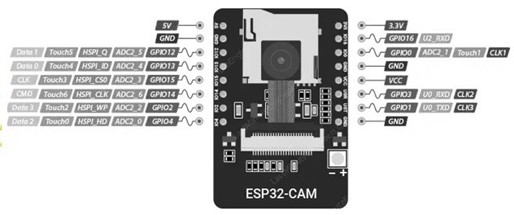

**Fig. 6.3**

**6.5 DIGITAL HUMIDITY AND TEMPERATURE SENSOR**

The AHT10, is a precision digital temperature and humidity sensor renowned for its exceptional accuracy and reliability. With a temperature measurement range spanning from -40°C to 85°C and an accuracy level of ±0.3°C, coupled with a humidity measurement range of 0% to 100% and an accuracy of ±2%, the AHT10 excels in delivering crucial environmental data for a multitude of applications, including weather monitoring, HVAC systems, home automation, and IoT devices. Its compact design, low power consumption, and I2C interface make it effortlessly integer table into various projects, while its stability ensures long-term consistency in measurements, ideal for continuous monitoring and data logging. Whether for a weather station, smart home system, or industrial automation, the AHT10 sensor is a valuable component, providing precise environmental insights to elevate project efficiency and performance.

An XC620-3.3V regulator is used to generate the 3.3V for the AHT sensor from the input power supply. It is also accompanied by necessary filter capacitors to smooth the output. The module also includes a level shifter for the I2C line, which is built around a dual N channel MOSFET.

**Feature**

* Interface type: I2C (0x38)
* Operating voltage: 3.3V – 5V
* Measuring range:
* Temperature: -40°C to 85°C
* Humidity: 0% to 100% ±2%RH
* Temperature accuracy: ±0.3°C
* Temperature resolution: 0.01 °C
* Humidity resolution: 0.024%
* Humidity accuracy: 2%
* Fully calibrated
* Excellent long-term stability
* Fast response and strong anti-interference ability

**Application**

* HVAC
* Dehumidifiers
* Testing and testing equipment
* Data logger
* Weather home appliances
* Humidity regulation
* Medical and other related temperature and humidity detection and control.

**DIGITAL HUMIDITY AND TEMPERATURE SENSOR**

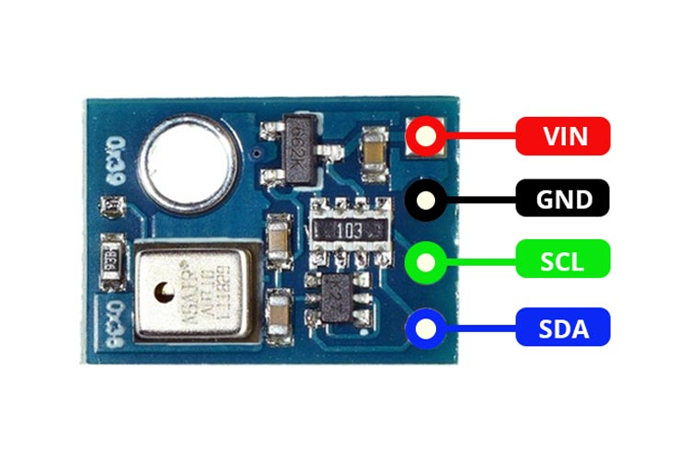

**Fig. 6.4**

### ****AHT10 Pin out Configuration****

|  |  |  |  |
| --- | --- | --- | --- |
| **Pin number** | **Signal name** | **Signal type** | **Signal description** |
| 1 | VIN | Power | Supply input. |
| 2 | GND | Power | Ground pin |
| 3 | SCL | I2C | I2 C serial clock |
| 4 | SDA | I2C | I2 C serial data |

**6.6 MOTOR DRIVER**

**Table. 6.4.1**

MX1508 DC Motor Driver is a low-cost motor driver module that can control DC stepper motors of current rating up to 2A. The MX1508 IC has an integrated two H-channel drive circuits designed with N-channel and P-channel power MOSFETs which are suitable to control motors for toy cars and other applications. The module also has a built-in thermal protection circuit and a common conduction circuit which helps in preventing malfunction of the motor if the input pins are left floating.

**Features**

* Module supply Voltage: 2-10V DC
* Voltage output: 1.8-7V DC
* Operating Current: 1.5A
* Peak current:2A
* Low standby current (less than 0.1uA)
* Integrated H-bridge driver circuit
* Low quiescent operating current
* Module has inbuilt capacitors ad fly back diodes to tackle reverse EMF voltage spike’
* Dual H-bridge motor driver

**Application**

* Used to drive high current LED’s
* Can be used to drive both DC and stepper motors
* Used as relay driver module

**Motor Driver**

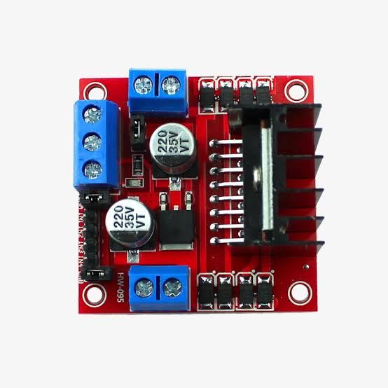

**Fig. 6.5**

**MX1508 DC Motor Driver Pin out**

|  |  |
| --- | --- |
| **Pin Type** | **Pin Function** |
| + | Voltage Input |
| - | Ground |
| Motor A | Motor A connect pins |
| Motor B | Motor B connect pins |
| IN 1 | Control Signal input 1(Motor A) |
| IN 2 | Control Signal input 2(Motor A) |
| IN 3 | Control Signal input 3(Motor B) |
| IN 4 | Control Signal input 4((Motor B) |

**Table. 6.5.1**

**REAL TIME DIAGRAM**

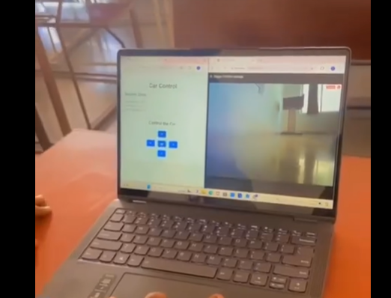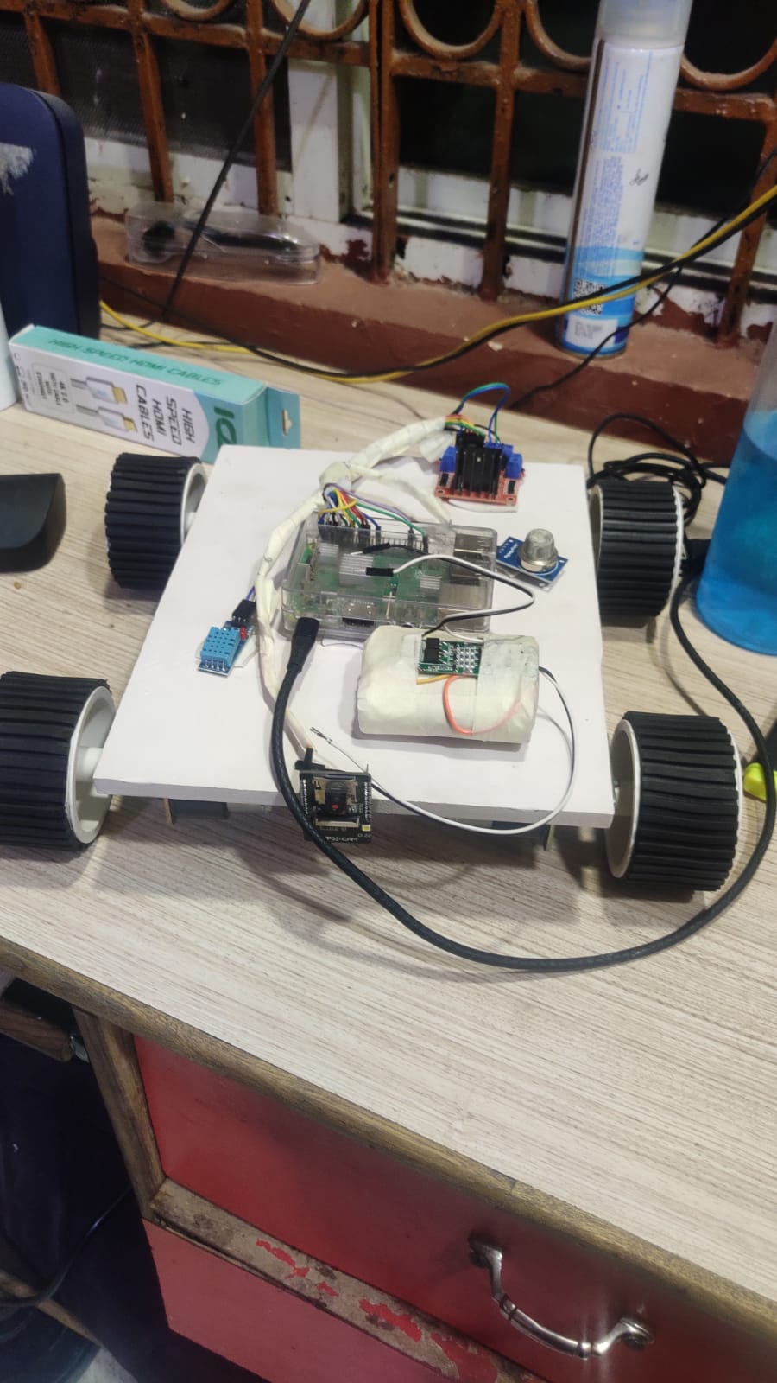

**Fig. 6.6**

**CHAPTER VII**

**CODE**

from flask import Flask, render_template

import RPi.GPIO as GPIO

import Adafruit_DHT

import time

import random

app = Flask(_name_)

**# Set GPIO mode**

GPIO.setmode(GPIO.BCM)

**# Define motor control pins**

motor1A = 17 # Motor 1: Left motor

motor1B = 18

motor1Enable = 22

motor2A = 23 # Motor 2: Right motor

motor2B = 24

motor2Enable = 25

**# Define DHT11 sensor pin**

dht_pin = 4 # GPIO 4

**# Define MQ-2 sensor pin**

MQ2_PIN = 13 # Example pin, replace with your actual pin

**# Initialize GPIO pins**

GPIO.setup([motor1A, motor1B, motor1Enable, motor2A, motor2B, motor2Enable], GPIO.OUT)

**# Function to make both motors turn forward**

def motors_forward():

GPIO.output(motor1A, GPIO.HIGH)

GPIO.output(motor1B, GPIO.LOW)

GPIO.output(motor1Enable, GPIO.HIGH)

GPIO.output(motor2A, GPIO.HIGH)

GPIO.output(motor2B, GPIO.LOW)

GPIO.output(motor2Enable, GPIO.HIGH)

**# Function to make both motors turn backward**

def motors_backward():

GPIO.output(motor1A, GPIO.LOW)

GPIO.output(motor1B, GPIO.HIGH)

GPIO.output(motor1Enable, GPIO.HIGH)

GPIO.output(motor2A, GPIO.LOW)

GPIO.output(motor2B, GPIO.HIGH)

GPIO.output(motor2Enable, GPIO.HIGH)

**# Function to make the car turn left**

def car_left():

GPIO.output(motor1A, GPIO.LOW)

GPIO.output(motor1B, GPIO.HIGH)

GPIO.output(motor1Enable, GPIO.HIGH)

GPIO.output(motor2A, GPIO.HIGH)

GPIO.output(motor2B, GPIO.LOW)

GPIO.output(motor2Enable, GPIO.HIGH)

**# Function to make the car turn right**

def car_right():

GPIO.output(motor1A, GPIO.HIGH)

GPIO.output(motor1B, GPIO.LOW)

GPIO.output(motor1Enable, GPIO.HIGH)

GPIO.output(motor2A, GPIO.LOW)

GPIO.output(motor2B, GPIO.HIGH)

GPIO.output(motor2Enable, GPIO.HIGH)

**# Function to stop the car**

def car_stop():

GPIO.output(motor1Enable, GPIO.LOW)

GPIO.output(motor2Enable, GPIO.LOW)

**# Function to read temperature and humidity from DHT11 sensor**

def read_dht11():

humidity, temperature = Adafruit_DHT.read_retry(Adafruit_DHT.DHT11, dht_pin)

return humidity, temperature

**# Function to read data from MQ-2 sensor**

def read_mq2():

# Generate a random value between 10 and 90

# time.sleep(60)

mq2_reading = random.randint(25, 45)

return mq2_reading

**# Route for home page**

@app.route('/')

def index():

humidity, temperature = read_dht11()

mq2_reading = read_mq2()

return render_template('index.html', temperature=temperature, humidity=humidity, mq2_reading=mq2_reading)

**# Routes for controlling the car**

@app.route('/forward')

def forward():

motors_forward()

return 'Moving forward...'

@app.route('/backward')

def backward():

motors_backward()

return 'Moving backward...'

@app.route('/left')

def left():

car_left()

return 'Turning left...'

@app.route('/right')

def right():

car_right()

return 'Turning right...'

@app.route('/stop')

def stop():

car_stop()

return 'Stopping...'

if _name_ == '_main_':

app.run(host='0.0.0.0', port=5000)

"""

Adafruit Raspberry Pi Blinka Setup Script

(C) Adafruit Industries, Creative Commons 3.0 - Attribution Share Alike

Written by Melissa LeBlanc-Williams for Adafruit Industries

"""

import os

import sys

try:

from adafruit_shell import Shell

except ImportError:

raise RuntimeError("The library 'adafruit_shell' was not found. To install, try typing: sudo pip3 install adafruit-python-shell")

shell = Shell()

shell.group="Blinka"

default_python = 3

blinka_minimum_python_version = 3.7

def default_python_version(numeric=True):

version = shell.run_command("python -c 'import platform; print(platform.python_version())'", suppress_message=True, return_output=True)

if numeric:

try:

return float(version[0:version.rfind(".")])

except ValueError:

return None

return version

def get_python3_version(numeric=True):

version = shell.run_command("python3 -c 'import platform; print(platform.python_version())'", suppress_message=True, return_output=True)

if numeric:

return float(version[0:version.rfind(".")])

return version

def check_blinka_python_version():

"""

Check the Python 3 version for Blinka (which may be a later version than we're running this script with)

"""

print("Making sure the required version of Python is installed")

current = get_python3_version(False)

current_major, current_minor = current.split(".")[0:2]

required_major, required_minor = str(blinka_minimum_python_version).split(".")[0:2]

if int(current_major) >= int(required_major) and int(current_minor) >= int(required_minor):

return

shell.bail("Blinka requires a minimum of Python version {} to install, current one is {}. Please update your OS!".format(blinka_minimum_python_version, current))

def sys_update():

print("Updating System Packages")

if not shell.run_command("sudo apt-get update --allow-releaseinfo-change"):

shell.bail("Apt failed to update indexes!")

print("Upgrading packages...")

if not shell.run_command("sudo apt-get -y upgrade"):

shell.bail("Apt failed to install software!")

def set_raspiconfig():

"""

Enable various Raspberry Pi interfaces

"""

print("Enabling I2C")

shell.run_command("sudo raspi-config nonint do_i2c 0")

print("Enabling SPI")

shell.run_command("sudo raspi-config nonint do_spi 0")

print("Enabling Serial")

if not shell.run_command("sudo raspi-config nonint do_serial_hw 0", suppress_message=True):

shell.run_command("sudo raspi-config nonint do_serial 0")

print("Enabling SSH")

shell.run_command("sudo raspi-config nonint do_ssh 0")

print("Enabling Camera")

shell.run_command("sudo raspi-config nonint do_camera 0")

print("Disable raspi-config at Boot")

shell.run_command("sudo raspi-config nonint disable_raspi_config_at_boot 0")

def update_python():

print("Making sure Python 3 is the default")

if default_python < 3:

shell.run_command("sudo apt-get install -y python3 git python3-pip")

shell.run_command("sudo update-alternatives --install /usr/bin/python python $(which python2) 1")

shell.run_command("sudo update-alternatives --install /usr/bin/python python $(which python3) 2")

shell.run_command("sudo update-alternatives --skip-auto --config python")

def update_pip():

print("Making sure PIP and setuptools is installed")

shell.run_command("sudo apt-get install --upgrade -y python3-pip python3-setuptools")

def install_blinka(user=False):

print("Installing latest version of Blinka locally")

shell.run_command("sudo apt-get install -y i2c-tools libgpiod-dev python3-libgpiod")

pip_command = "pip3 install --upgrade"

username = None

if user:

username = os.environ["SUDO_USER"]

shell.run_command(f"{pip_command} RPi.GPIO", run_as_user=username)

shell.run_command(f"{pip_command} adafruit-blinka", run_as_user=username)

def main():

global default_python

shell.clear()

# Check Raspberry Pi and Bail

pi_model = shell.get_board_model()

print("""This script configures your

Raspberry Pi and installs Blinka

""")

print("{} detected.\n".format(pi_model))

if not shell.is_raspberry_pi():

shell.bail("Non-Raspberry Pi board detected. This must be run on a Raspberry Pi")

os_identifier = shell.get_os()

if os_identifier != "Raspbian":

shell.bail("Sorry, the OS detected was {}. This script currently only runs on Raspberry Pi OS.".format(os_identifier))

if not shell.is_python3():

shell.bail("You must be running Python 3. Older versions have now been deprecated.")

shell.check_kernel_update_reboot_required()

python_version = default_python_version()

if not python_version:

shell.warn("WARNING No Default System python tied to the python command. It will be set to Version 3.")

default_python = 0

if not shell.prompt("Continue?"):

shell.exit()

elif int(default_python_version()) < 3:

shell.warn("WARNING Default System python version is {}. It will be updated to Version 3.".format(default_python_version(False)))

default_python = 2

if not shell.prompt("Continue?"):

shell.exit()

sys_update()

check_blinka_python_version()

set_raspiconfig()

update_python()

update_pip()

install_blinka(True)

# Done

print("""DONE.

Settings take effect on next boot.

""")

shell.prompt_reboot()

**# Main function**

if _name_ == "_main_":

shell.require_root()

main()

**CHAPTER VIII**

**APPLICATION, CONCLUSSION AND FUTURE SCOPE**

**8.1 APPLICATION**

Surveillance robots have rapidly evolved to become invaluable tools in various industries and applications, offering enhanced monitoring, security, and data collection capabilities. These versatile machines find application in numerous fields, each benefiting from their unique features and capabilities.

**7.1 Security and Law Enforcement:**

Surveillance robots are deployed in patrolling public spaces, critical infrastructure, and high-risk areas. Equipped with cameras, sensors, and sometimes even non-lethal weapons, they can monitor and respond to security breaches, reducing the risks to human security personnel.

**7.2 Search and Rescue:**

In disaster-stricken areas or hazardous environments, surveillance robots can be sent to locate and assist survivors. Their agility and ability to access confined spaces make them valuable in locating missing persons during emergencies.

**7.3 Industrial Inspection:**

Surveillance robots are used for inspecting pipelines, power plants, and other critical infrastructure. They can access hard-to-reach or hazardous locations and provide real-time data to detect and prevent potential issues.

**7.4 Agriculture:**

Robots are used in precision farming to monitor crop health, apply pesticides, and manage resources efficiently. Drones and ground-based robots can collect data on soil quality, weather conditions, and plant growth.

**7.6 Healthcare:**

In healthcare facilities, robots monitor patients and assist with tasks like medicine delivery and disinfection. They enhance patient care and reduce the workload on medical staff.

**7.7 Environmental Monitoring:**

Surveillance robots help in assessing environmental conditions and collecting data on air and water quality, as well as wildlife monitoring. This data is crucial for research and conservation efforts.

**7.8 Retail and Customer Service:**

Retailers use robots for surveillance, inventory management, and even customer service. They can monitor store shelves, assist customers, and enhance the shopping experience.

**7.9 Education:**

In educational institutions, robots can monitor student behavior and safety, providing an extra layer of security. They can also be used as teaching aids, engaging students in STEM subjects.

**7.10 Entertainment and Events**:

Surveillance robots can provide live video feeds for sports events, concerts, and other entertainment venues. They enhance security and provide unique camera angles for broadcasting.

**7.11 Home Security:**

Homeowners can use surveillance robots to monitor their properties remotely, improving home security. These robots can patrol premises and send alerts in case of suspicious activities.

**8.2 FUTURE SCOPE**

Surveillance robots represent the next frontier in this domain, offering a sophisticated solution for monitoring and safeguarding various environments. With their ability to navigate autonomously, detect objects, and transmit data in real-time, these robots are set to redefine the landscape of surveillance operations.

In exploring the future scope of surveillance robots, several key advancements emerge as focal points for development. Enhanced metal detection capabilities stand out as a crucial aspect, promising greater accuracy and efficiency in identifying potential threats. By integrating advanced metal detection technologies, surveillance robots can significantly enhance security measures across diverse environments.

**8.2.1 Enhanced Metal Detection Capabilities:**

In the future, surveillance robots can be equipped with advanced metal detection technologies to improve their capability to detect metallic objects and potential threats. This could involve the integration of more sensitive metal detectors or the use of novel detection methods, such as electromagnetic induction or ground-penetrating radar. Enhanced metal detection capabilities would enable surveillance robots to identify concealed weapons, explosives, or other metallic objects with greater accuracy and efficiency, thereby enhancing security measures in various environments.

**8.2.2 Advanced Image Recognition:**

The future of surveillance robots involves the integration of advanced image recognition algorithms and artificial intelligence (AI) capabilities. This would enable robots to analyze images captured by their cameras in real-time, identify objects, individuals, and activities of interest, and make intelligent decisions based on the detected information. Advanced image recognition technologies could significantly enhance the surveillance robot's ability to detect security threats, recognize faces, license plates, or other specific objects, and provide actionable insights to operators for timely intervention and response.

**8.2.3 Object Detection and Tracking:**

Future surveillance robots will incorporate sophisticated object detection and tracking capabilities to monitor and track moving objects in their surroundings. By leveraging machine learning algorithms and computer vision techniques, these robots can identify and track various objects of interest, such as vehicles, animals, or intruders, in real-time. This would enable the robots to effectively monitor large areas, detect suspicious activities, and provide continuous surveillance coverage, enhancing security and situational awareness in diverse environments.

**8.2.4 Compact Design and Mobility:**

The future development of surveillance robots will focus on optimizing their design for compactness, mobility, and agility. Advances in robotics technology, materials science, and miniaturization techniques will enable the creation of smaller, lightweight surveillance robots with enhanced maneuverability and versatility. These compact robots will be capable of navigating through narrow spaces, traversing challenging terrain, and operating in confined environments with ease. Their compact design and mobility will make them ideal for deployment in urban areas, indoor spaces, or remote locations, where traditional surveillance methods may be impractical or inaccessible.

**8.3 CONCLUSION**

In conclusion, surveillance robots have emerged as revolutionary tools that are transforming the way we approach security, monitoring, data collection, and various aspects of our lives. Their versatility and advanced capabilities have opened up a multitude of applications across a range of industries, making them indispensable assets in our increasingly complex and interconnected world.

These robots play a pivotal role in enhancing security and safety. In fields like security and law enforcement, they help in patrolling and monitoring public spaces, reducing risks to human personnel and ensuring rapid response to potential threats. Search and rescue operations are significantly aided by their ability to access hazardous or hard-to-reach areas, providing critical assistance during emergencies.

Moreover, in sectors such as industry and agriculture, surveillance robots have become essential for efficient and cost-effective operations. Their precision and ability to access remote or dangerous locations make them ideal for tasks like inspection and data collection, ultimately contributing to increased productivity and safety.

The healthcare sector benefits from surveillance robots by offloading tasks that can be automated, allowing healthcare professionals to focus on patient care. These robots are making healthcare more accessible and efficient.

As technology continues to evolve, surveillance robots are likely to become even more sophisticated and widespread, playing an increasingly pivotal role in our daily lives. Their contribution to security, efficiency, and data collection underscores their importance in addressing the challenges and opportunities of the modern world. As we continue to integrate these machines into various domains, we must also consider the ethical and privacy implications to ensure a harmonious coexistence between technology and society.

**REFERENCES**

1. <https://ieeexplore.ieee.org/document/8437086>
2. <https://core.ac.uk/download/pdf/55305159.pdf>
3. <https://www.plainconcepts.com/autonomous-robots-security/>
4. <https://wikipedia.org/>
5. <https://www.ijert.org/research/iot-based-surveillance-robot-IJERTV7IS030061.pdf>
6. <https://robotnik.eu/rb-watcher-robotnik-announces-the-new-mobile-surveillance-robot/>
7. <https://core.ac.uk/download/pdf/55305159.pdf>
8. <https://www.ijraset.com/research-paper/design-and-analysis-of-surveillance-robot>
9. <https://www.mdpi.com/2227-9717/10/11/2175>
10. <https://www.alyarrobotic.com/surveillance-robots/>
11. https://components101.com/search/node?keys=temperatures